Minutes from the Steering committee meeting
544169–TEMPUS–1–2013-1-BE-TEMPUS-JPCR
Competency based Curriculum Reform in Nursing and Caring in Western Balkan Universities

Dates: 8-9-10/07/2015

Venue: Odisee, University College, Brussels

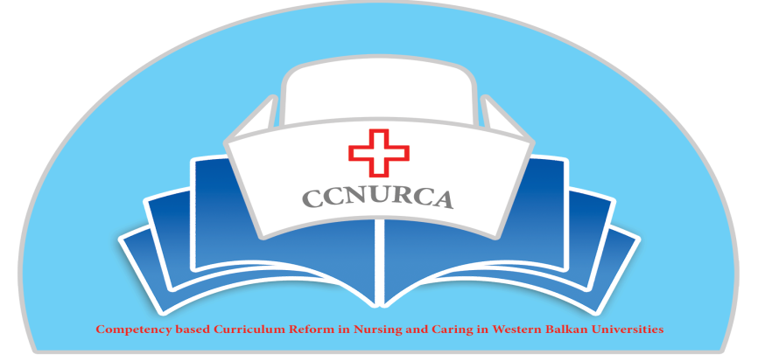

Activity: Preparation of 'Train the trainer' sessions in Shkodra, Albania

Brussels, 8- 10 July 2015

- In Brussels, 8-10 July 2015, steering committee was held within TEMPUS project CCNURCA ''Preparation of 'train the trainer' in Shkodra in Albania''. The meeting was attended by the steering committee. The EU partners also invited some lecturers that will be involved in the training sessions. (see list in Annex)
- The main topics of the meeting were:
  - Preparation of the LP's monitoring visit in Albania.
  - Purpose, target audience and high level planning of the training in Shkodra.
  - Learning needs following the curriculum reform in the WB countries.
  - Proposals of content and teaching methods for the training in Shkodra.
  - Practical planning and organisation of the training.

8 th of July 2015
Preparation of the LP's monitoring visit in Albania.
- 9-11 September 2015 the LP and the core members of the WB will visit the Albanian partner institutions. Mutual expectations are expressed (timing accessibility, transparence and positive attitude).
- Visitors:
  - Dejan Bokonjic (University of East Sarajevo)
  - Mirza Oruc (University of Zenica)
  - Filip Dumez (LP, Odisee)

- Travel times and practicalities were negotiated. Ardian Cerava from university Fn S. Noli, Korce will guide the monitoring visit. He asks the participants to travel early in the morning for practical planning.
9th of July 2015
- The meeting started with a welcome and the presentation of the agenda. Filip Dumez, representative of project coordinator institution, Odisee, presented the agenda. The agenda was adopted and accepted by all participants.
- Prof. dr. Dejan Bokonjic stated that the purpose of this meeting is the high level planning of the meeting in Shkodra, 7-9 September 2015. During this meeting we need to decide which teaching methods will be used during the training.
- Cultural differences and advice about these cultural differences were stated and accepted by the WE partners.
- Purpose of the training: presented by Mirza Oruc, representative of University of Zenica and Prof. dr. Dejan Bokonjic.
  - Methodology in the teaching process => can be seen as a tool to implement in every university.
  - The level of training is discussed.
- Target audience, content and modalities are discussed, the discussion is guided by Mirza Oruc, representative of University of Zenica and Prof. dr. Dejan Bokonjic. Major issues:
  - 3 trainees per university.
  - Precondition: good understanding and speaking of the English language + teachers who have the skills to present and translate this knowledge to their own university and other teachers.
  - ± 5 groups, use of a rotation system and groups will be mixed by steering committee.
  - Use of plenary sessions for the theoretical parts.
  - Every evening reflection about the training will be held.
  - Training will be held in English.
  - Remark of Prof. dr. Dejan Bokonjic: In the next fase of the project WE-partners will monitor the fase of translation to other teachers in different universities in a dissemination seminar.
  - Remark of Filip Dumez, representative of project coordinator institution, Odisee: There is an agreement about the competencies that shall be used. These can be found in the concluding remarks of the 'international meeting in Zenica' 04/06/2014. Focus now is on the design of the training.
- Proposals of content and teaching methods.
  - Patrick Janssens of Odisee, University College.
    - Content: Simulation and debriefing as a method to improve non-technical skills and attitude.
    - 1,5 hour plenary session
    - 1,5 hour workshop in small groups of 4- 5 persons
      - Remark of the steering committee:
      - 1 hour plenary session
      - 7 persons per group
      - The proposal was adopted by the steering committee.
  - Lubica Rybarova and Stefania Andrascikova of University of Presov.
    - Content: Clinical skills training using case studies and mind mapping, a method to improve critical thinking and ability to plan nursing interventions.
    - Integration of case study and mind mapping.
    - 30 minutes plenary session.
    - 1 hour 30 minutes workshop.
      - The proposal was adopted by the steering committee.
  - Maarten Kaaijk and Johan Wieren of Hanze Hogeschool, Groningen.
    - Content: Learning principles, reflection and communication skills.
    - PBL: problem based learning and communication skills.
    - 30 minutes plenary session.
    - 1 hour 30 workshop
      - The proposal was adopted by the steering committee.
  - Kathy Pletinckx and Lieselot Van Droogenbroeck from Odisee, University College.
    - Content: Alternative teaching methods.
    - Agreement about Portfolio.
    - 30 minutes plenary session.
    - 1 hour 30 workshop.
      - The proposal was adopted by the steering committee.
  - Prof. dr. Dejan Bokonjic.
    - Content: 4 step Payton + OSCE
    - 45 minutes plenary session.
    - 1 hour 15 workshop.
    - Rotating groups, 5 stations, 15 minutes per station.
      - The proposal was adopted by the steering committee.
  - Srdjan Masic of University of East Sarajevo
    - Campus
    - Training software: interactive, case based multimedia learning.
    - Presentation of Campus.
    - 1-hour plenary session.
      - The proposal was adopted by the steering comimttee

10th of July 2015.
- Presentation of the agenda by Filip Dumez and Prof. dr. Dejan Bokonjic.
- Refining the practical planning and organisation of the training in Shkodra.
- The schedule below represents the practical program
7/9/'15 | 8/9/'15 | 10/9/'15
9:00- 10:00  Introduction and presentation of the agenda  Expectations | 9:00-9:15  Presentation of the agenda | 9:45- 10:00 (? Niets over gezegd)  Presentation of the agenda
10:00-10:30  Plenary session  Overview of alternative teaching methods. (Kathy Pletinckx and Lieselot Van Droogenbroeck) | 9:15-10:15  Plenary session  Debriefing (Patrick Janssens) | 10:00-10:30  Plenary session  PBL (Maarten Kaaijk?)
10:30-11:00  Plenary session  Mind map. ( Lubica Rybarova and Stefania Andrascikova. | 10:15-11:15  4 groups, rotation system  1 group: Workshop debriefing (Patrick Janssens)  1 group: Plenary session: Communication skills (To Be Defined)  1group: Plenary session: Campus (Srdjan Masic)  1 group: lunch  10:15- 11:15 I II III IV  11: 15- 11:30 Coffee break  11: 30- 12:30 II I III IV  12:30- 13:30 IV I III II  13:30- 14:30 IV II III I  Legend:  Debriefing, Patrick Janssens  Campus: Srdjan Masic  Communication skills:  Lunch | 10:30-12:00  Workshop PBL  3 groups  Maarten, Johan and Dejan
11:00-11:30  Coffee break | 14:45- 16:30  Reflection | 12:00-13:00  Lunch
11:30-13:00  Workshop  4 groups, 2 different workshops, rotating system, duration per workshop: 45 minutes.  WS 1: Alternative teaching methods, given by 2 trainers.  WS 2: Mind mapping, given by 2 trainers.  11:30- 13:00 SK Lubica SK Stefania B Lieselot B Kathy  14:00- 15:30 B Lieselot B Kathy SK Lubica SK Stefania | 16:15  Conclusion | 13:00-13:45  Plenary session  Payton + OSCE  13:45-15:00  Workshop Payton + OSCE  4 groups
13:00-14:00 Lunch break | 17:15 Trainer meeting | 15:00- 16:00  Reflections
14:00-15:30 Workshop | 18:00 Social event + dinner | 16:00  Ceremony
15:30-15:45 Coffee break
16:00- 17:00
Plenary session: reflection
Trainer meeting
19:00 social event
20:00 Dinner
- The proposal of the agenda for 'train the trainer' in Shkodra was adopted by the steering committee.
- Presentation of the final training schedule for the training in Shkodra (content, needs, travelling schedule,…)
  - Deadlines
  - 15th of August: Every trainer will give the correct information to Ardian Cerava about the practical needs for the training.
  - 15th of August: information, practicalities, number of rooms, internet,…: mail to Dejan Bokonjic.
  - By the 1st of September: every partner will make a list of all participants and give it to Mirza Oruc.
  - 1st of September: Synthetisation of expectations: mail to Mirza Oruc.
  - 1st of September: Every methodology: Sheet of 1 page with description of methodology: mail to Dejan Bokonjic.
- The training ended with concluding remarks from Prof. dr. Dejan Bokonjic and Filip Dumez. They stated that the preconceived progression was accomplished

