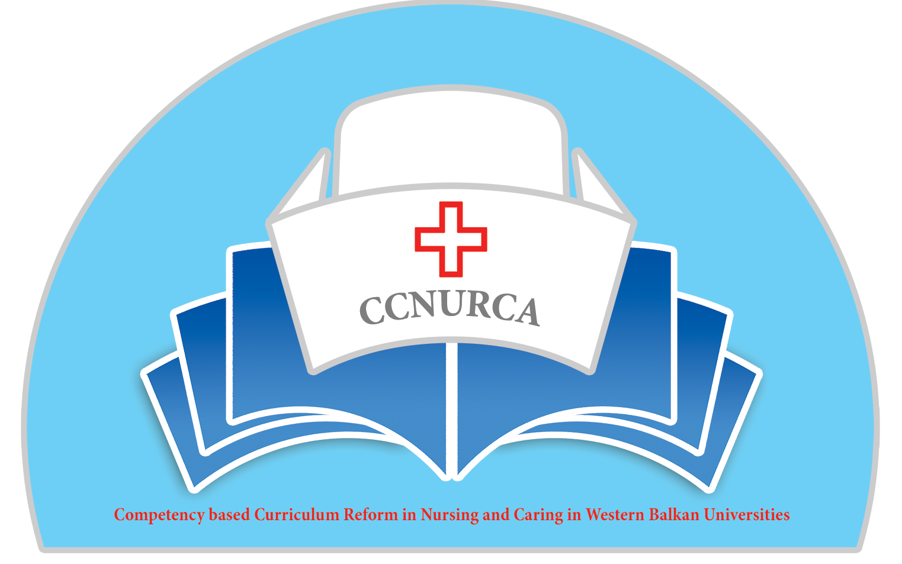

Agenda

Monitoring-CCNURCA project
Korca, 14-17.07.2016

Venue: University of Korca

Thursday, 14 July 2016

Arrival of participants

Friday 15 July 2016

10.00 Welcome

Welcome and presentation of agenda
Mr. Dejan Bokonjic, University of East Sarajevo
Mr. Ardi Cerava , University of Korca

10.15-11.00 Presentation of activities performed until now in
CCNURC-a project on University Korca

11.00-13.30 Analysis of activities and discussion-all members of
Korca team

13.30-14.30 Sightseeing tour-University of Korca

14.30-15.30 Lunch break

15.30-16.30 Analysis of existing curriculum-staff members

Saturday 16 July 2016

10.15-11.00 Analysis of teaching methodologies and assessment
methodologies -

11.00-11.30 Analysis of existing curriculum –management team

11.30-12.00 Analysis of existing curriculum-students

12.00-12.30 Conclusions and oral report to the REctor

Saturday 16 July 2016

Departure of participants

Project management team

